

**BACHELOR OF TECHNOLOGY  
IN  
COMPUTER SCIENCE AND ENGINEERING**

**AT**

**KNOWLEDGE PARK III, GREATER NOIDA, UTTER PRADERSH**

**SECURITY WRIST BAND FOR WOMEN**

**A Project Report Submitted**

**In the partial fulfillment of the requirements of the degree of**

**Bachelor of Technology in Computer Science and Engineering**

**Submitted by:**

**Vareesh Ahmed (2018002828)**

**Aman Raj (2018002902)**

**Nadeem Khan (2018008370)**

**Shubham Saini (2018013926)**

**Supervised by:-**

**Dr. Hoor fatima, Asst Professor (CSE)**

April, 2022

[i]

**CERTIFICATE**

This is to certify that the project entitled **“Security Wrist Band for Women”** submitted by

“Mr. Vareesh Ahmed (2018002828), Mr. Aman Raj (2018002902), Mr. Subham Saini

(2018013926), Mr.Nadeem Khan (2018008370)” to sharda university towards the fulfillment of the

Requirements of the degree of ‘Bachlore of Technology’ is a record of bonafied final year project

Work carried out by in the “Department of Computer Science and Engineering, School of

Engineering and Technology, Sharda University”

The results/findings contained in this project have not been submitted in part or full to any other

University/Institute for award of any other degree/diploma.

Signature of Supervisor

Dr. hoor Fatima (Asst. prof)

Signature of Head of Department Signature of External Examiner

Prof. Dr. Nitin Rakesh

[ii]

**ACKNOWLEDGEMENT**

A major project is a golden opportunity for learning and self-development. We consider our self very lucky and honored to have so many wonderful people lead us through in completion of this project.

First and foremost, we would like to thank Dr. Nitin Rakesh, HOD, CSE who gave us an opportunity to undertake this project

My grateful thanks to Dr. Hoor Fatima mam for her guidance and support in our major project work. who in spite of being extraordinarily busy with her academics, took

Out time to hear, guide and keep us on the correct path. We do not know where we would have been without her help.

**CSE** department, monitored our progress and arranged all facilities to make life easier. We choose this moment to acknowledge their contribution gratefully

**Name and Signature of Students**

Vareesh Ahmed (2018002828)

Aman Raj (2018002902)

Nadeem Khan (2018008370)

Subham Saini (2018013926)

[iii]

**ABSTRACT**

This Security Wrist Band for Women narrates about the Women’s Safety band. Women are cladding unusual and immoral physical molestation everywhere. This obtains a rapid tempo due to lack of an acceptable monitoring system. Women I every society needs her security to go outside and feel comfortable. Nowadays, we witnessing numerous crimes related to women physical harassment. Location like latitudes and longitudes and the live streaming of videos using the hidden cam is integrated in the smart band that reacts as a great tool of the technology. We believe that this system will bring a great revolution the live of Women of every society. The idea of this research is to create a clever, intelligent security system for women. Women are subjected to a great deal of unethical physical harassment all throughout the world. Due to a lack of an appropriate surveillance system, this develops at a rapid rate. Our effort is an attempt to solve this issue. These everyday things, a bracelet and wristband, are combined in this project. The system resembles a wristband with a pressure switch as an input that, when activated, displays the outcome. Screaming alarms and tear gas are used for self-defense, and the system sends location and messages to emergency contacts, as well as allowing the assailant to be identified via live streaming video. The glasses have a tear gas mechanism and a camera for live streaming video. From birth to death, children and women perform critical roles in our society. Crime against children and women has increased significantly in recent years. They are dealing with a variety of insecurity-related issues. We hear more about women's harassment than their achievements. One of the most serious violations of human rights is the trafficking of women and children. However, measuring the scope of the problem is challenging since trafficking is closely linked to child labour, bonded labour, child marriage, kidnapping and abduction, and prostitution, even though these problems might occur irrespective of trafficking. They are powerless in such situations and have no possibility of protecting themselves or contacting their family, neighbours, or the police station, and they feel handicapped. Several applications and smart security solutions, such as armbands, bracelets, jackets, smart toys, smart watches, and wristbands, are being deployed for both children and women to resolve these concerns.

This detailed review evaluates the advantages and disadvantages of various techniques and systems offered by various researchers. We presented an improved system that uses to address the drawbacks of previous solutions.

[iv]

**CONTENTS**

*Title page ……………………………………………………………………………………………………… i*

*Certificate ……………………………………………………………………………………………………..ii*

*Acknowledgement …………………………………………………………………………………………...iii*

*Abstract …………………………………………………………………………………………………………iv*

*INTRODUCTION …………………………………………………………………………………………….6*

* 1. *Problem overview ………………………………………………………………………………………..7*

*LITERATURE SURVEY ……………………………………………………………………………………….8*

*SYSTEM ANALYSIS AND DESIGN………………………………………………………………….…….10*

*3.1 Hardware Requirements………………………………………………………………………………10*

*3.2 Flowchart ……………………………………………………………………………………………….11*

*3.2 Block Diagram ……………………………………………………………………………………….…12*

*FEASIBILITY ANALYSIS ……….………………………………………………………………………....13*

*4.1 Economic Feasibility ………………………………………………………………………….………13*

*4.2 Technical Feasibility ………………………………………………………………………….………13*

*4.3 Resource Feasibility ………………………………………………………………………….………13*

*4.4 Time Feasibillity ……………………………………………………………………………….…….13*

*Objectives…………………………………………………………………………………………….…….14*

*RESULTS****/****OUTPUTS………………………………………………………………………………..…….15*

*CONCLUSION ……………………………………………………………………………….…….……...16*

*REFRENCES ………………………………………………………………………………………………..17*

**INTRODUCTION**

Nowadays, women's safety is changing into a serious matter, such related application do survive, and these square measures fairly good to seize the sufferer mobile. Here we have a tendency to introduce a smart safety band that provides the Defense of women. This assists to spot the Women that supplicate things to assist from unhealthy things. The major motive behind this product is to generate safety as well as security. Being the associate freelance nation, the women around the world are not safe. The system agrees for knowing the exact location of the ladies who have this smart band. Once the band is tapped and approach, that is at a planned angle, and so the message is delivered mechanically to the selected contact list. The SMS which holds the position information in Latitude as well as line of longitude which holds a shock mechanism for defense. It sends the lats-and-longs to the premeditated contact information in the format of lat’s and long. When the sufferer strike women and at that time shock circuit is employed to punish the aggressor for defense.

Harassment of children and women is becoming more frequent by the day. They are always scared of getting kidnapped. Physical harassment of women and children is increasingly commonplace in public places, schools, and workplaces, as well as when travelling. In India, rape is the fourth most prevalent crime against females.There were 56,709 rape cases filed in India alone, conferring to the 2017 annual report of the National Crime Records Bureau (NCRB). The number of rape cases reported has risen significantly during the previous decade. The bulk of physical harassment claims come from women who are alone or travelling. Women are apprehensive about leaving the house. There are a lot of Android apps for cell phones, but there aren't many for people who don't have one. Despite the Indian government's creation of a lot of efficient rules and regulations to address and In the prevention of crimes against women, the incidence of such crimes continues to rise. In recent years, the country's treatment of women has become increasingly disrespectful and awful. Women's trust in their own country has been eroded as a result. We should not clutch the government accountable since women's safety is everyone's duty, not just the governments.Women in India, previously regarded as the improved half of the population, are now the most defenseless group in terms of safety and security. This clearly indicates that such sexual overdrives are becoming more popular among today's youth.

[6]

In India, sexual assault is the fourth greatest prevalent crime committed against females. Conferring to the latest National Crime Records Bureau (NCRB) annual report from 2013, 33,707 rape cases have been registered in India alone. Over the last decade, the number of recorded rape cases has significantly increased. A step toward reducing the number of cases of this horrible crime is to create a technology that can automatically detect oncoming danger and assist in the rescue of the victims. According to research, similar devices are commercially available, however they require manual button pressing to activate the alert. Because the emotional condition of women and children is influenced during such acts, physical button pushing is not optimal. The inhabitants of India must undertake certain basic responsibilities in order to contribute to the establishment of an order that ensures women's dignity and respect, allowing them to exercise their human and With pride, freedom, and assurance, we exercise our fundamental rights. To do this, civilization must work organized to offer the solution an advantage. For example, women in society should be given gadgets with cutting-edge technology that can transmit messages with her address to surrounding sites or reveal her location to a central police control room via GPS technology. After the horrific rape and homicide of a Nirbhaya, a 23-year-old student, in Delhi on December 6th. has placed a greater emphasis on the need for comprehensive sanctuary and protection measures for women. Unfortunately, despite robust legislation, occurrences of sexual assault and physical abuse of women have not decreased, highlighting wider socio-political issues and environmental changes in Indian culture today. The fundamental tendencies may appear to be abnormalities in male conduct, but they have grown so evident in recent times, and their negative effects have become so harmful to society as a whole, that they require outright declaration. Many individuals and groups all around the world have long been concerned about it. It becomes clear when we consider many events throughout the world in which the identity of a woman has been misconstrued by a few persons in society, and an attempt has been made to damage a woman. While it may takes decades or centuries for the world to become a safer place for us, there are a number of things we can—and must—do to safeguard ourselves. Sadly, despite strong legislation, occurrences of assault and physical abuse of women have not decreased, indicating wider socio-political issues and environmental variations in Indian culture today. The fundamental patterns might appear to be abnormalities in masculine behaviour, but they have grown so pronounced in recent years, and their negative belongings have become so harmful to civilization as a whole, that they require open declaration.

[7]

**Problem overview**:

* To plan an encapsulated system for women defense with ability to recognize pulse rate and body temperature and to mark their movement in case of emergencies and will take required actions.
* To be a practical, adequate and suitable device that can be worn on women’s wrist.
* Insufficient user authentication was the most prevalent issue. Every smartwatch examined lacked two-factor authentication or the ability to lock accounts after several unsuccessful login attempts.
* When it comes to security, certain smart watches have a bad reputation. Take a look back: Hewlett-Packard conducted a research study in 2015 that discovered serious security flaws in the top smartwatch devices at the time of testing.
* Your smartphone is extended by smart watches and other wearable gadgets. They provide you access to applications, email, text messages, and the internet right away.
* Smart watches gather a great amount of information about us. This may be the number of steps you took and where you travelled in a day, or financial information if your device is capable of making payments or most importantly our health and fitness data. Depending on the applications we've installed and the personal information you've supplied, the list expands.
* Privacy policies are included with smart watches, whether they be Apple or Android devices or any other recognized brand . You can find out how much or how little information is shared by reading the policy.
* Insufficient user authentication was the most prevalent issue. Every smartwatch examined lacked two-factor authentication or the ability to lock accounts after several unsuccessful login attempts.

[8]

**Literature Review**

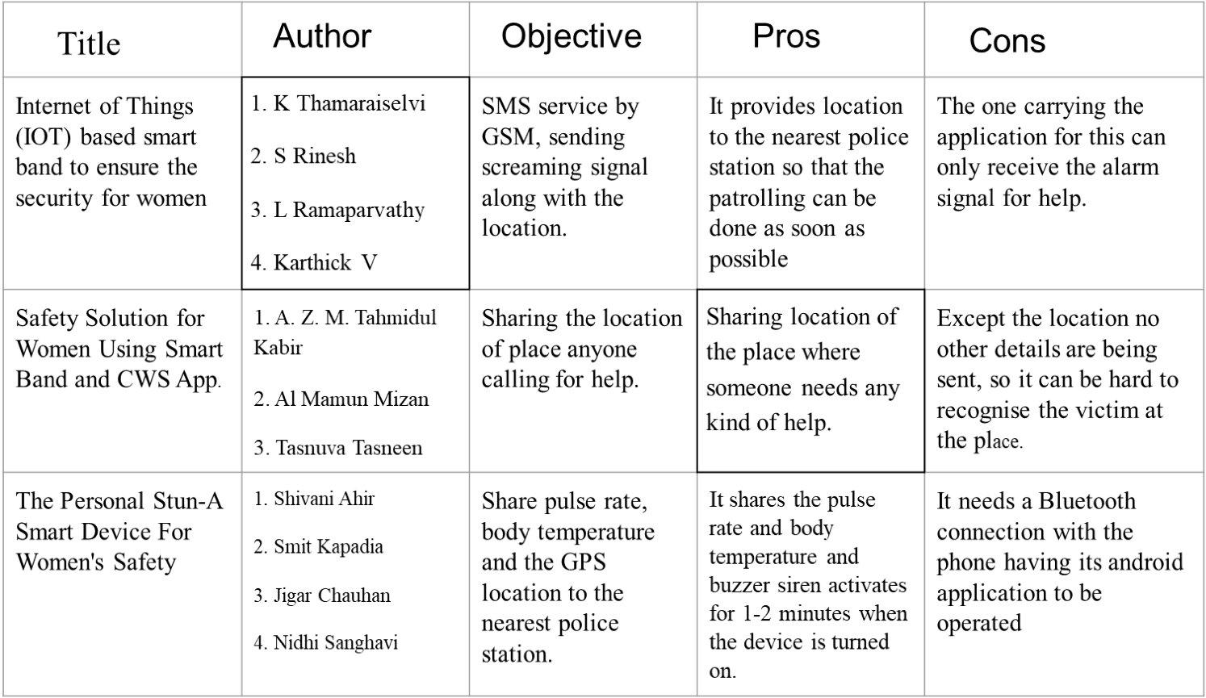

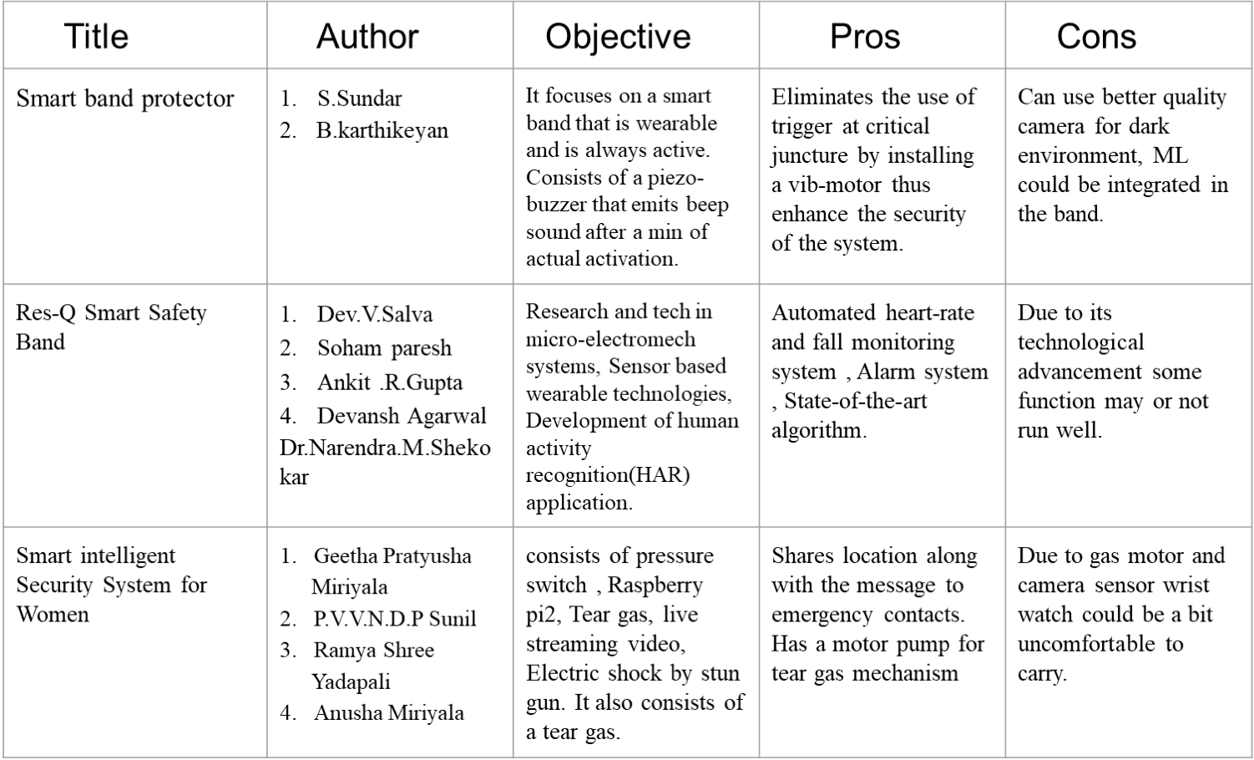

[9]

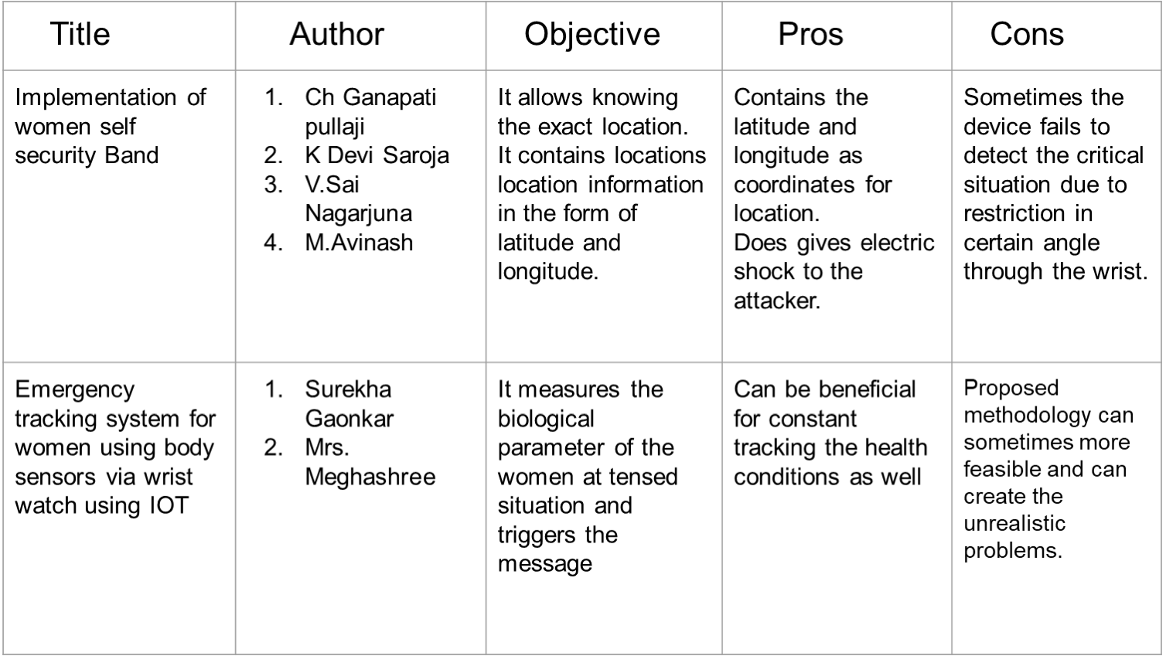

[10]

**Cont….**

Furthermore, projects such as VithUapp, Nirbhaya, and the Spot N Save Feel Secure app have been released. However, the majority of them had far more problems than positives. The VithU smartphone app was the first to come up with the concept. When the user experiences a challenge in this programme, the contacts on the list receive alert messages, which may be stored previously. The message is delivered to the previously saved contact, along with their actual position. However, the downside of this software is that we must press the power button twice in a row, which is impossible in this case. Nirbhaya, a Pune-based software firm named that after Delhi gang Rape, was created in 2012. In an emergency situation involving a lady, It has the ability to transmit a distress signal to a chosen communication group. They will send an SMS alert to the selected group, indicating the woman's geolocation through GPS. Every 300 metres of movement, it is also updated. Users can create their own contact list, which might include police officers and others in the area & family and friends.

Another big disadvantage of the software is that it is materially linked, which hasn’t always conceivable.

The Sport N Save Feel Secure app is a distinctive portable smart band that acts in accordance with it. This software works by sending a signal to the protector network by pressing the button on the band twice. Every two minutes, the signal will be updated. This app is not suitable for all scenarios since users cannot make an alert before by clicking it twice in an undetected condition or at an unexpected moment.

Stay Safe (SOS) is additional useful personal safety software that protects you from violent activities and assists someone in an emergency. SOS – Stay Safe is an app that can help you stay safe in a variety of risky scenarios, including being followed on your way home, tried physical or sensual assault, domestic abuse, traffic coincidences, and health problems. The device works by hitting the phone's power key three times in a row. It sends an alternative message to friends and family that includes your position and device battery level. This app enables you to seek assistance quickly and quietly deprived of arousing doubt.

[11]

The recipients can follow your exact location thanks to the GPS tracking. This program also has a drawback, that is why is also not the most efficient application.

The Res-Q Smart Safety Band comes with a 120db private alarm, a high-intensity LED flash bulb, a security hammer, and a belt buckle, a portable charger, and a cutter However, since it is not very portable. They can't be carried around with you all the time. It do not provide any information.

declaration that this gadget can be used in all situations young woman are on the go.

This technology, according to our paper, may be carried when travelling. This mobile software has a message notification feature as well as a calling option. If the observed pulse is greater than a certain threshold then, a message is directed to all emergency contacts and the nearest police station, along with precise GPS position. This phone application also has the option to cancel. If the pulse fluctuation is caused by something else, the app also has a cancel option. The message is cancelled if the cancel button is touched.

[12]

**ANALYSIS AND DESIGN**

This design has been incorporated using an Arduino Uno interfaced with accelerometer, GSM and GPS systems in a scalable form to be adjustable to different types of position marking. Depending on the total plan of the process, the hardware and software of the process is a real-time observing system where the situation of women and position feature in order to provide instant help.

During any emergency, the person wearing the wrist band has to click on the button for the help seeking messages to be sent to her parents, nearby police station or the contacts they have chosen to send the emergency notification.

Triggering the emergency button will let the GPS module get the latitude and longitude of the band from the satellite and it will push it to the Arduino Nano. Then the Arduino Nano will send an SMS to the preloaded numbers in the Arduino Board through the GSM module connected through it (as shown in the Fig.5 below) and will send the message to the preloaded sim number with a message seeking for emergency help along with the latitude and longitude details of the person wearing the wrist band.

By this women can send an instant help seeking message along with our location for emergency help in time. This may ensure women more towards their safety and security.

Heartbeat is one of the major noticeable changes a person carries when they are in a panic situation. A human’s normal heartbeat rate is approximately 72 beats per minutes. This is examined on a large set of daily resting heartbeat databases gathered.

In a routine visit to a doctor usually experience the measurement of resting heartbeat rate by the doctor before examine to any other part of the body. This is done to see if the person's heartbeat is stable to the required rates or not. The analysis done from the large amount of dataset concludes that a person’s daily normal heartbeat rate varies from one individual to another on the basis of various attributes; such as gender, age, Body Mass Index (BMI), average daily sleep and their physical body routine.[5]

Categorising these facts together we can come to an approach to trigger our SOS in the extreme situation of fear or nervousness. The studies show that it is possible to characterise the different frequencies of heartbeat rates in different stress situation a person is in.

[13]

While a person is in stress, the heartbeat rate complexity is also affected. There are some researches which study the changes in the heartbeat rate’s frequency with respect to the short-term stress or panic and in the chronic stress situation. Body being responding to the situations is the simulation of the brain which directs the hormones to act accordingly. This can be used in order to track the heartbeat behaviour of a person in different situations or mental conditions.[6]

The heartbeat rate frequently reflects some known changes in some situation of panic or stress can be used as the trigger for this security wrist band. The band has to capture and regularly monitor the heartbeat frequency of the wearer and has the subject’s heartbeat rate knowledge in different stress situations. Finding out the situation where the heartbeat of the wearer is having unusual changes the band can act as a messenger to the person’s family members notifying them about that unknown frequency of the heartbeat of the band wearer. This will help the family person know that the person is in some kind of stress in that particular time and might be in the need of some help.

The SOS button shown in the Fig.6 below will be triggered with the help of a heartbeat rates sensor connected to it in order to trigger the button while there is an unusual change in the frequency of heartbeat of the person, which will be occurred in the situation of sudden stress or panic. Study shows there are different frequencies of the pulse rate in different mental state occurred by the situation being faced at that time. These frequencies can be different for different person according to their gender, age, physic, average daily sleep, diet and their daily routine.[5] These helps keeping the track over usual or normal heartbeat rates of that person which helps the sensor to detect the unusual or unknown frequencies that encounter in the situation of sudden stress or panic.

Having the previous data of the person’s normal heartbeat rates in different situations, it could be saved in order to have more accuracy over the successful detection of unusual heartbeat rate frequencies. This may include sudden run with pace, stopping from walking suddenly, heart beating faster in less time, etc. which can sense some different frequencies other than the person gets usually under any known calm situation.

[14]

Code for Arduino

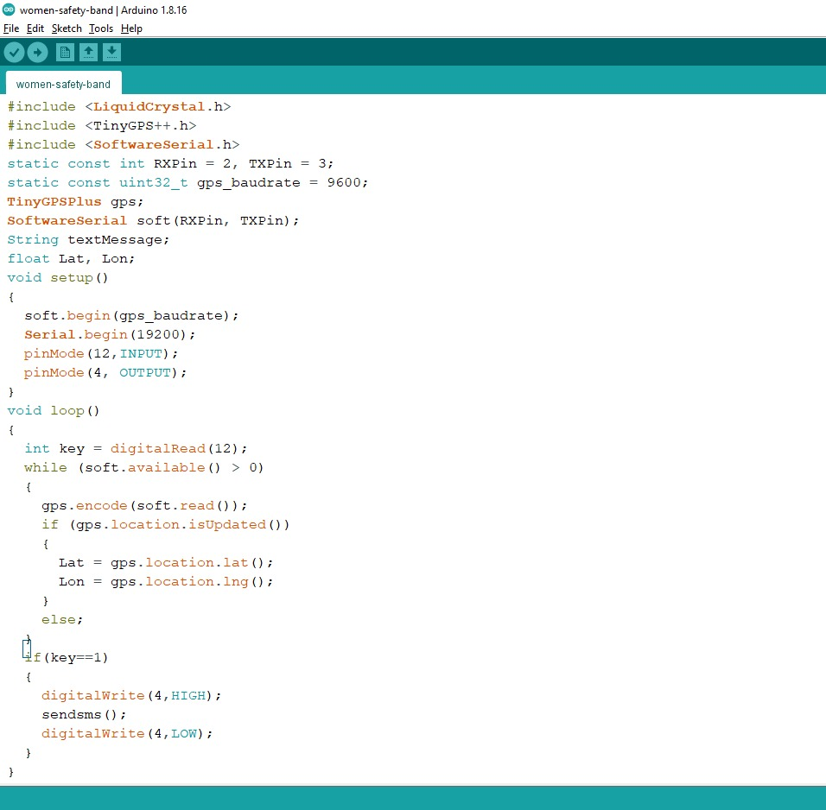

[15]

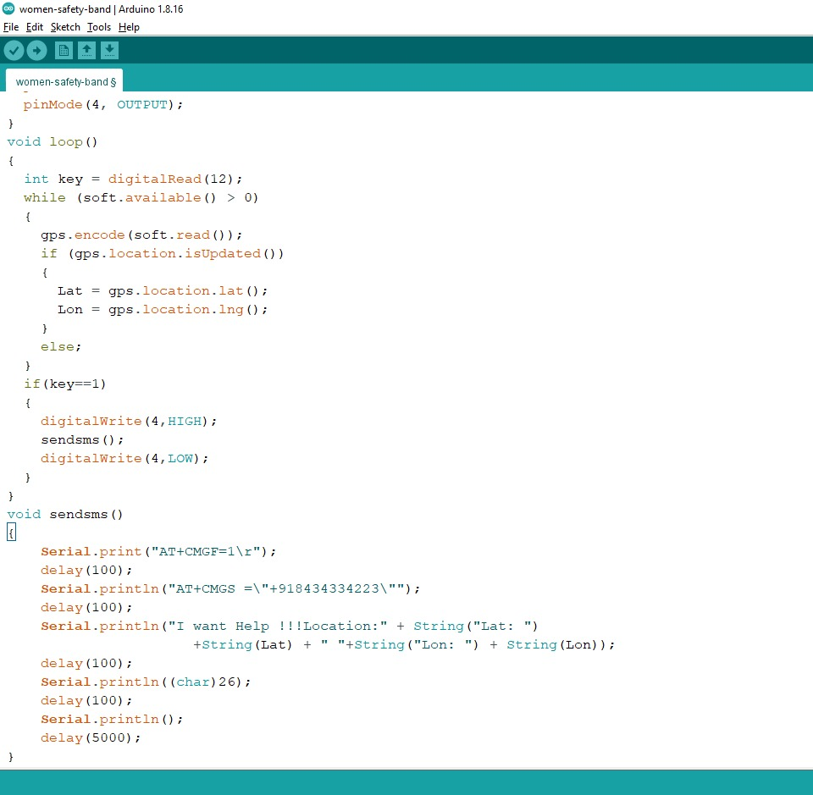

[16]

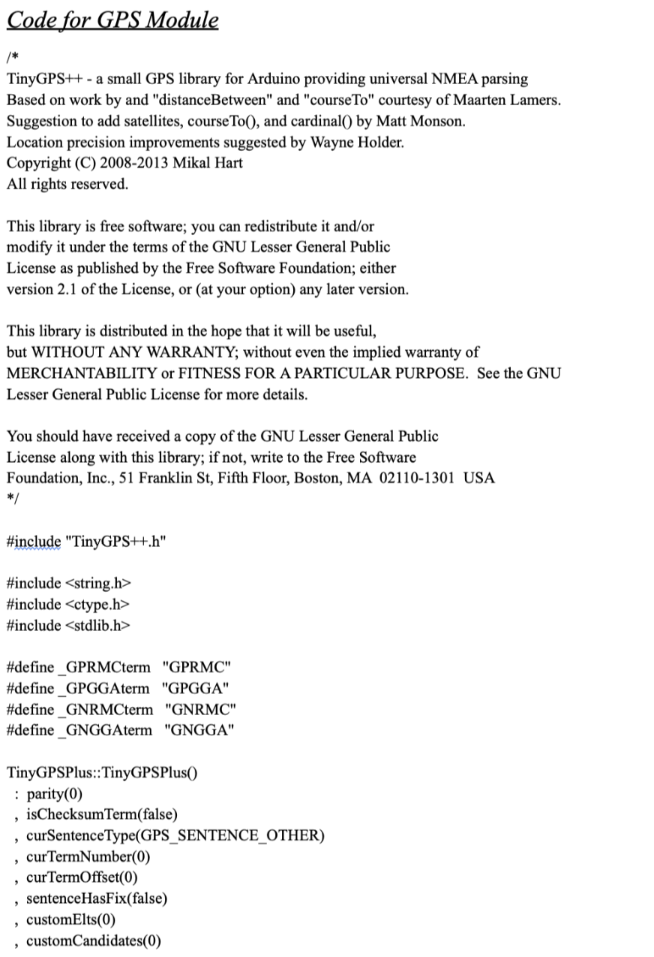

[17]

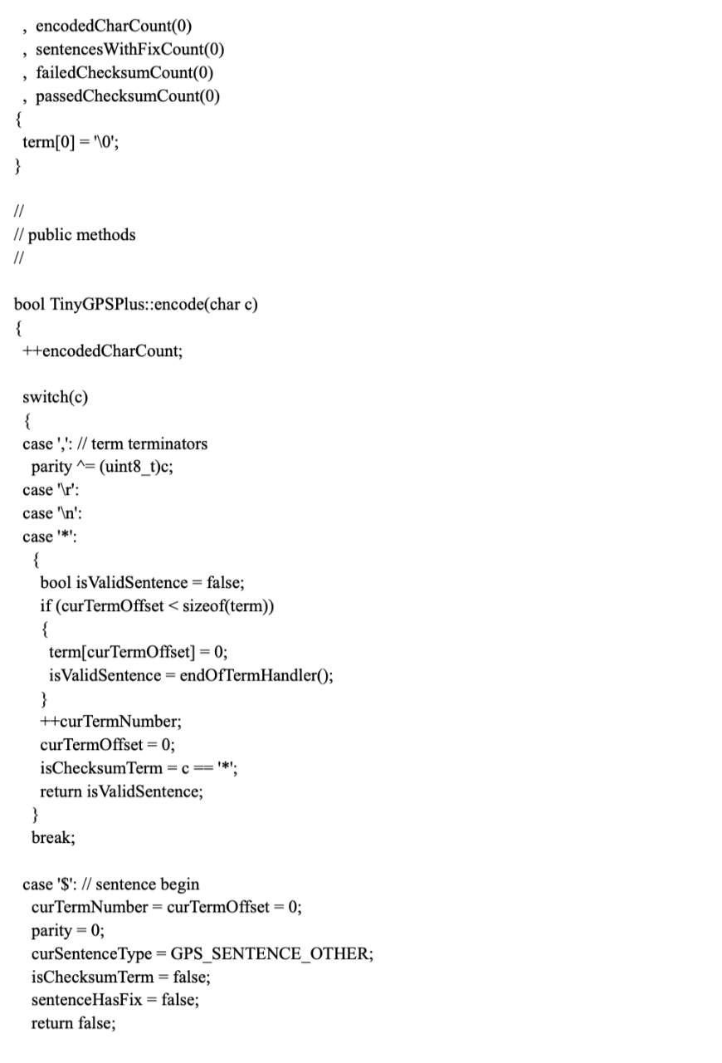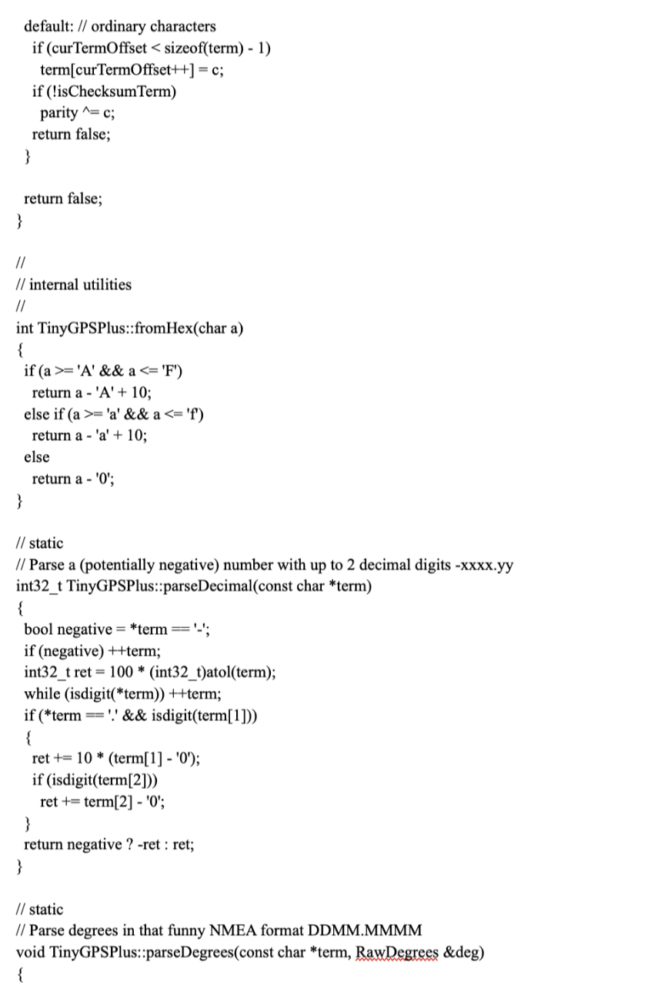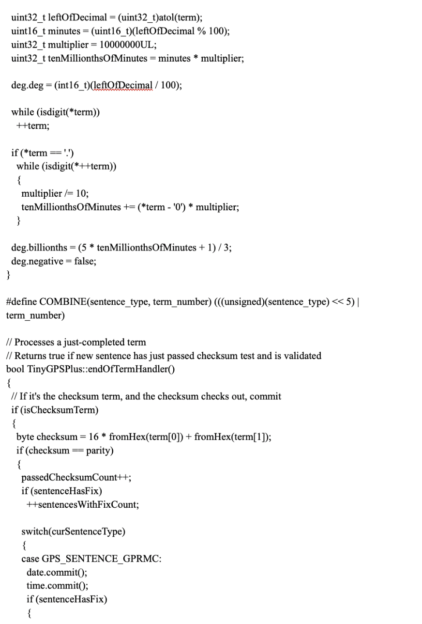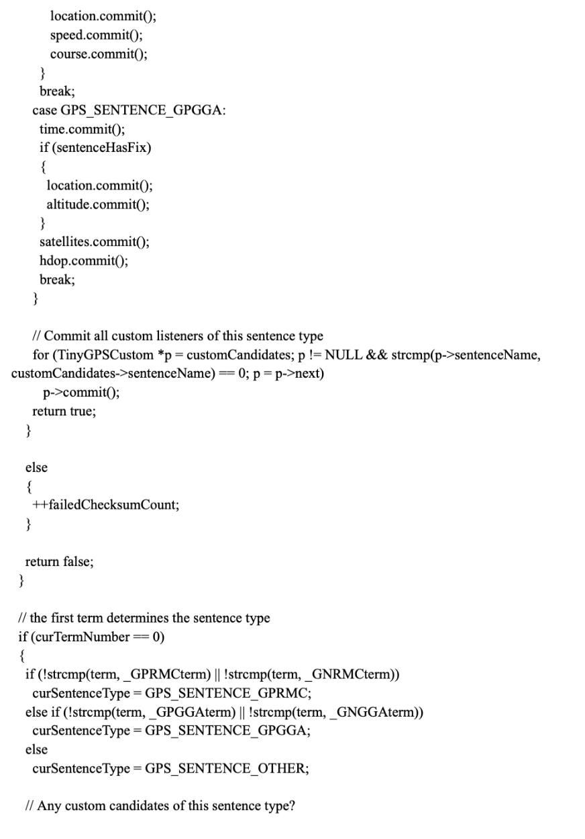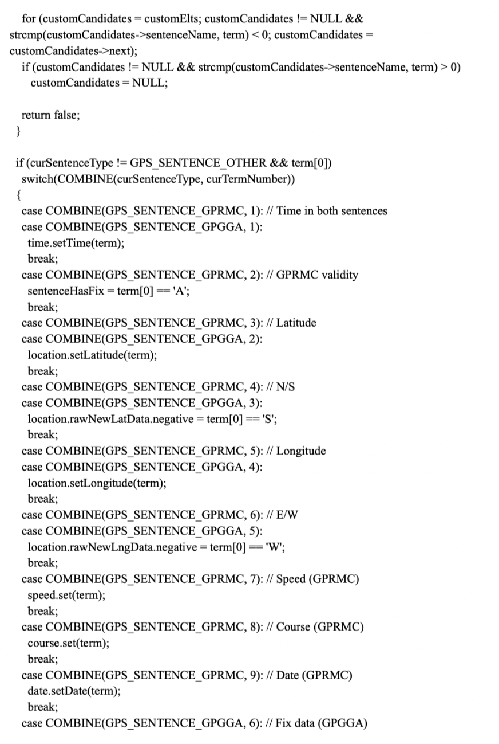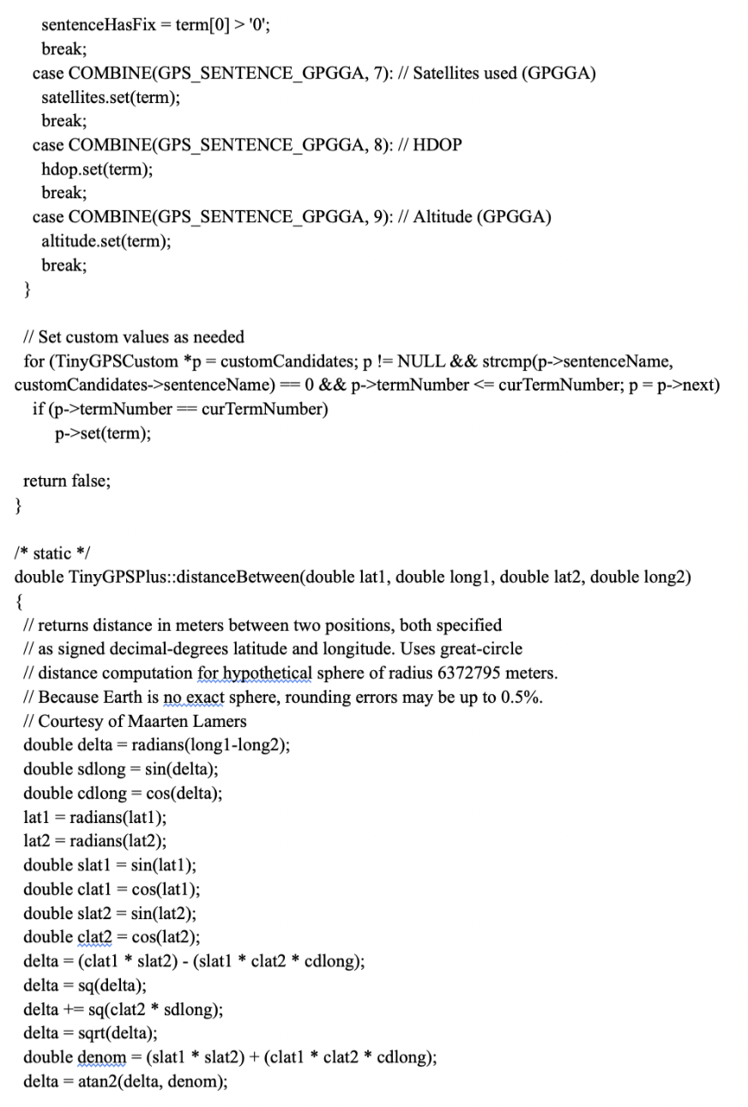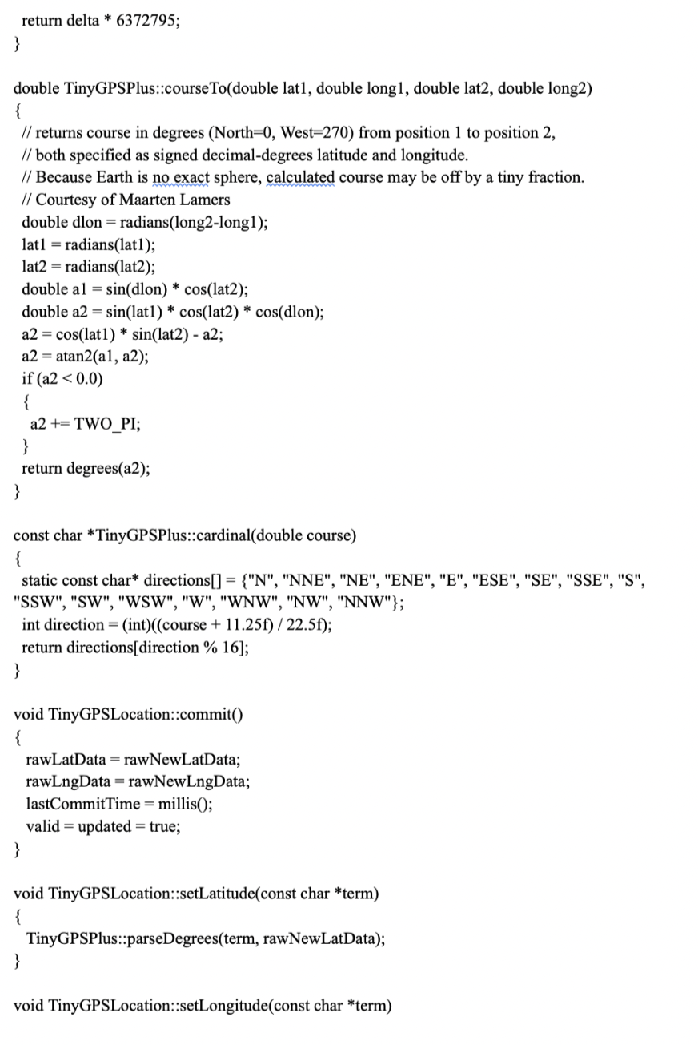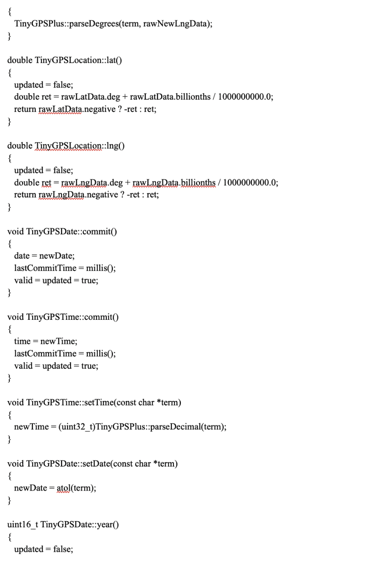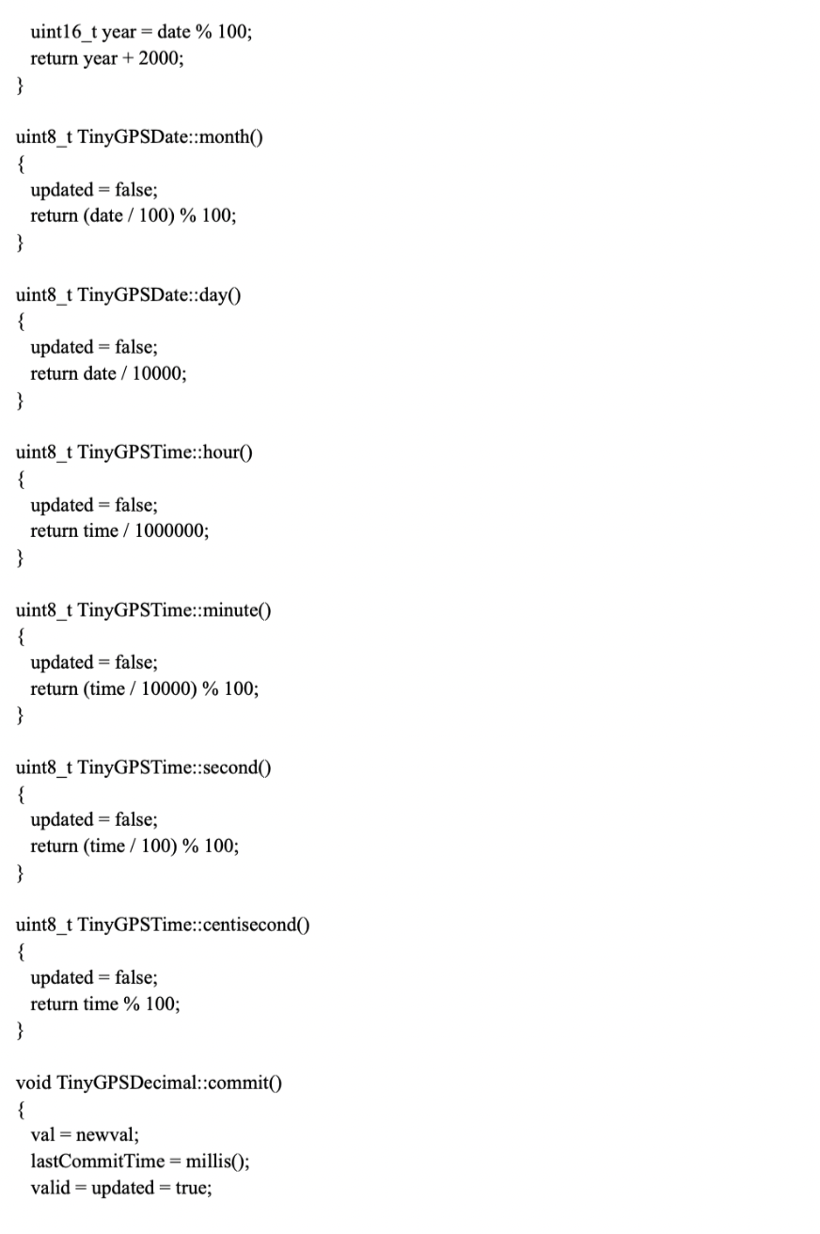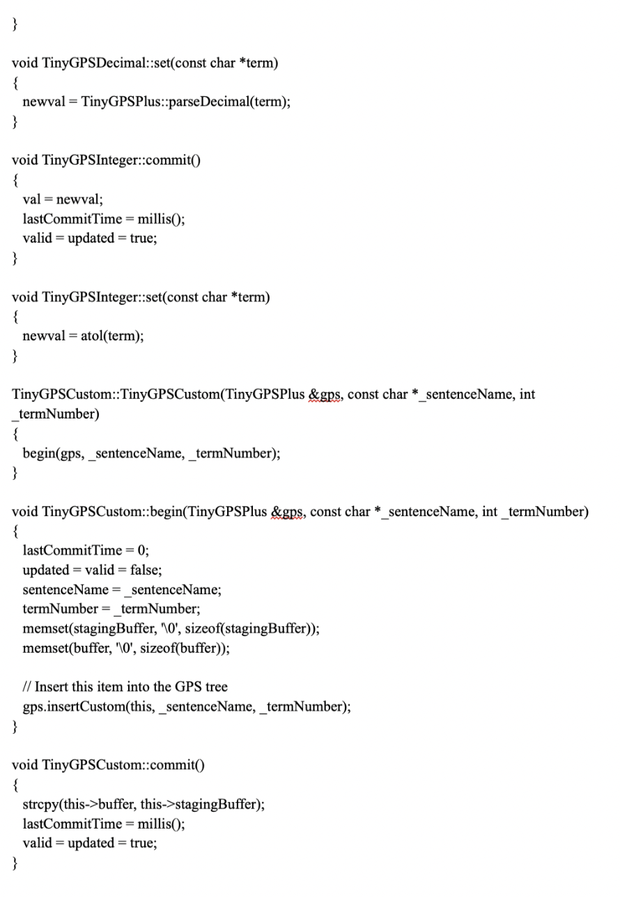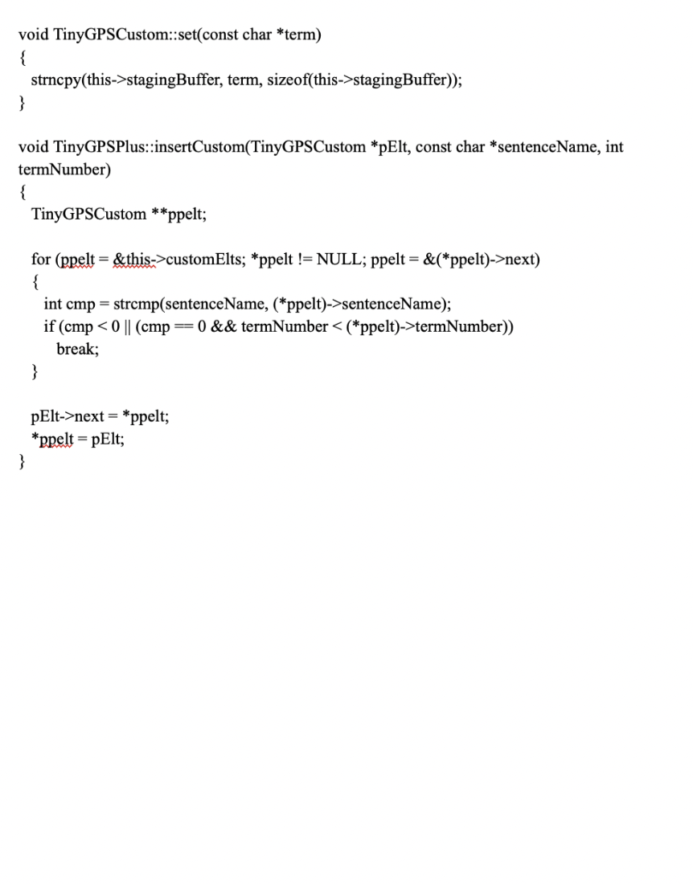

[18]

[19]

[20]

[21]

[22]

[23]

[24]

[25]

[26]

[27]

[28]

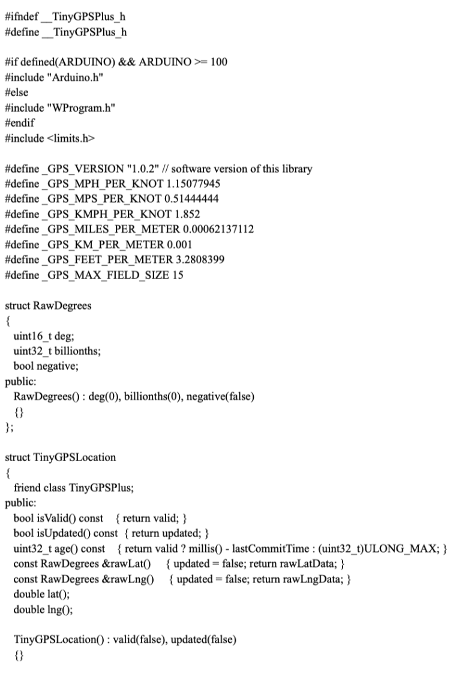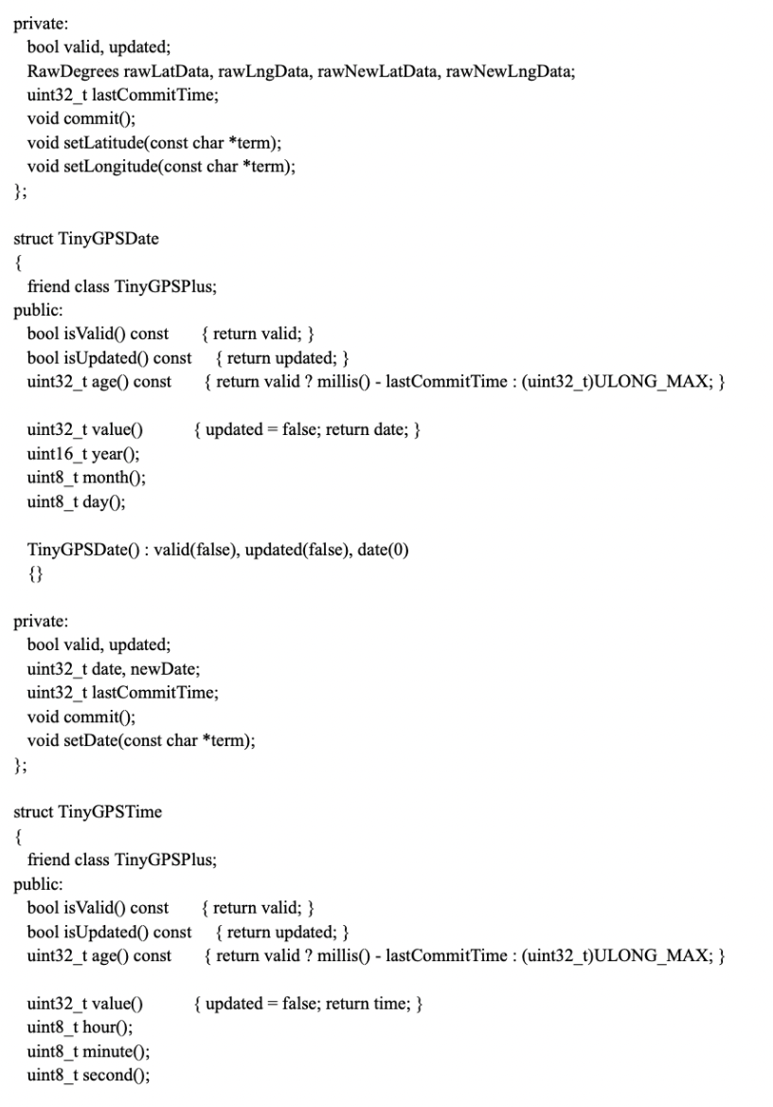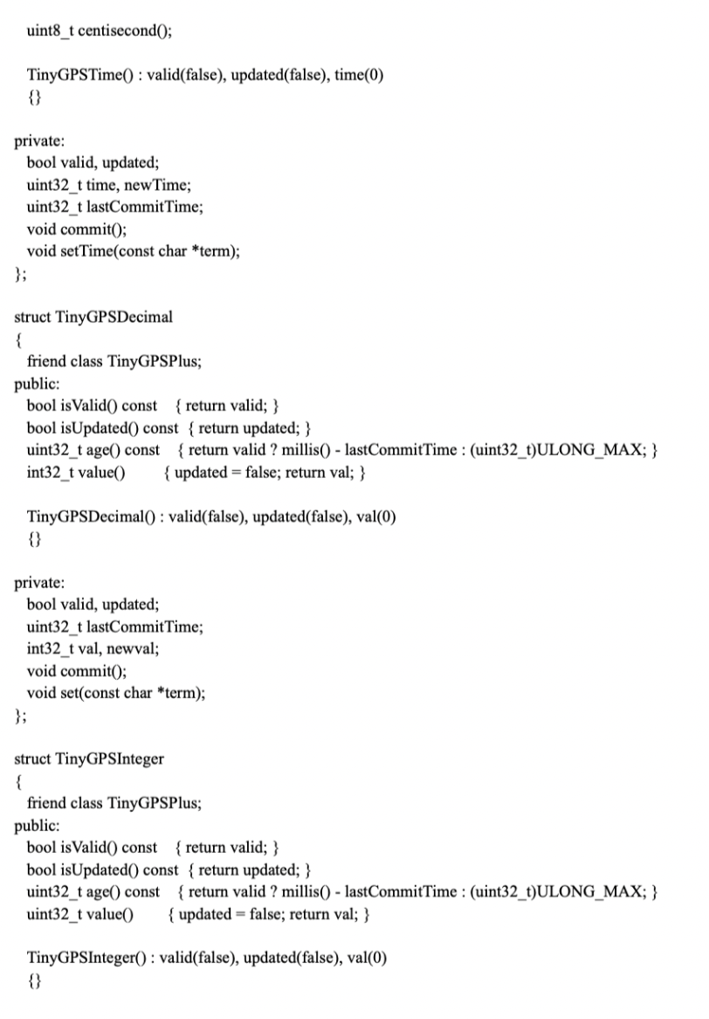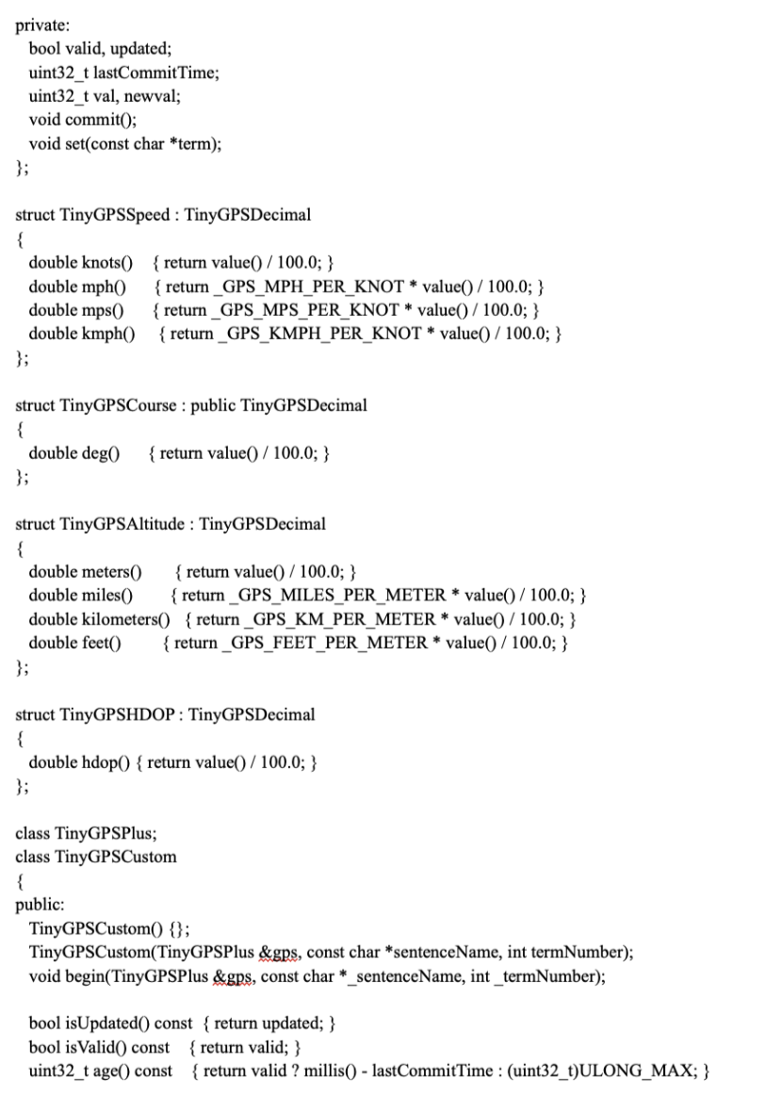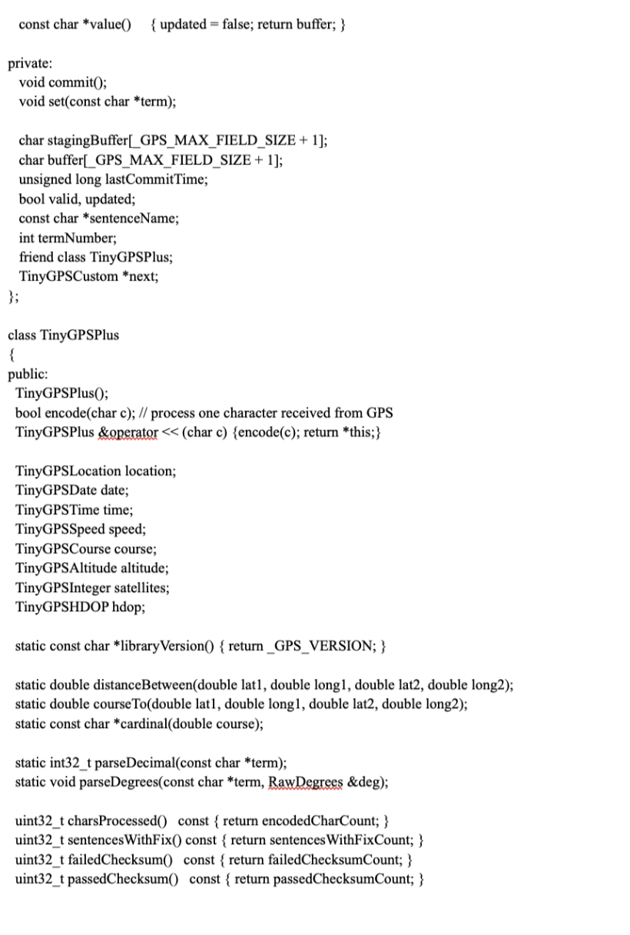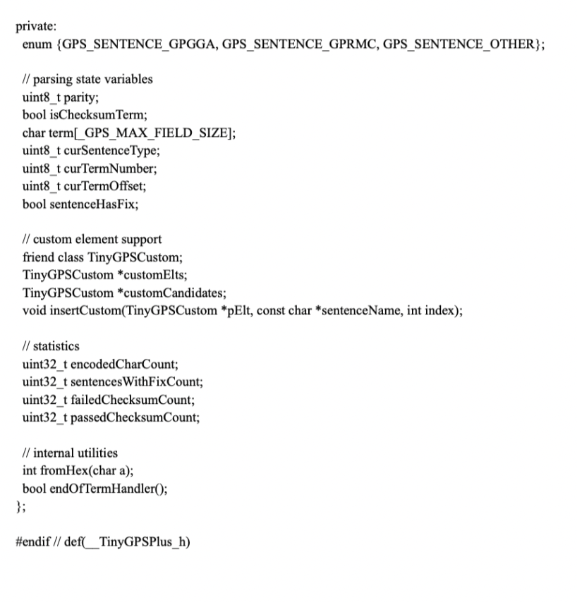

[29]

[30]

[31]

[32]

[33]

[34]

*Hardware Requirements:*

Ardiuno nano

The Arduino Nano is a compact, feature-rich, and breadboard-compatible board shaped ATmega328.

It has a lot of the same characteristics as the Arduino Duemilanove, but it comes in a different packaging. Instead of using a Micro-B USB connection, it has a DC power connector. a conventional one.

Its operating voltage ranges from 5V. It consumes approx. 9mA of power. This ardiuno nano is a open source hardware means everyone can build their own ardiuno nano board.

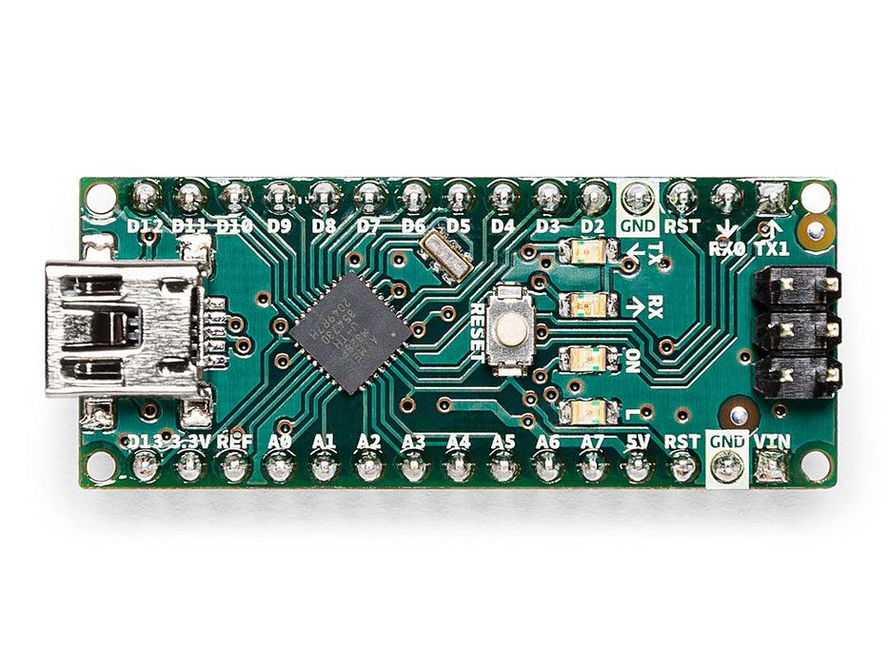

[35]

GSM Module

A GSM electronic equipment or GSM component is hardware equipment that operates GSM phone telephonic technology to come up with a nexus to a distant matrix.

The GSM network, which is used by cell phones, provides a low-cost, long-range wireless communication channel for apps that require connection but not high data speeds. Industrial refrigeration and freezers, air conditioning and vending machines, and automobile maintenance, among other things, may benefit from being connected to a GSM system.

On the rear, there's a SIM slot! Any 2G micro SIM card that has been activated will function fine. The correct direction for inserting a SIM card is usually inscribed on the SIM socket's surface. This module is barely 1 inch, 2 in size, yet it packs a remarkable amount of functionality into its little chassis.

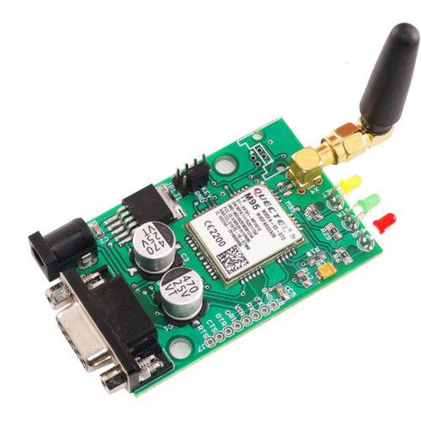

[36]

GSM Sim Tool

SIM Application Toolkit (STK) a normal of the GSM system that lets the subscriber identity module (SIM) card to start off measures which could be used for several value added assistance.

A GSM modem is a particular form of modem that accepts a SIM card and works on a mobile operator's subscription, much like a phone. A GSM modem appears to a mobile operator to be similar to a mobile phone. When a PC is connected to a GSM modem, the computer may interconnect via the mobile network using the GSMmodem.

The SIM900A does have an industry-standard interface and provides GSM/GPRS900/1800MHz voice, SMS, data, and fax capabilities in a compact low-power-consumption form factor. With a small footprint of 24mm x 24mm x 3mm, the SIM900A can accommodate practically every space requirement in your applications, particularly for slim and compact design demands.

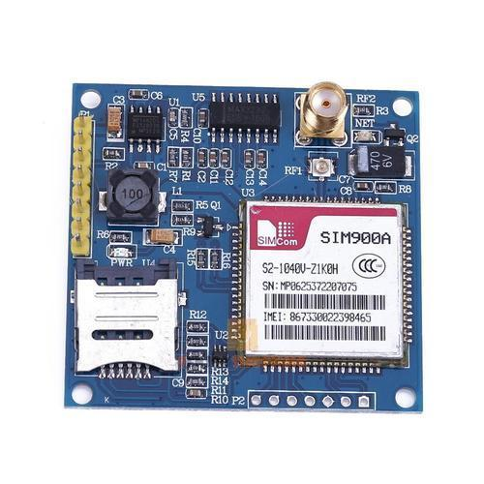

[37]

SOS Switch

If your car is involved in an accident and the SOS button is connected to eCall, the eCall system instantly alerts the emergency services. If your automobile is engaged in an accident, the eCall technology instantly alerts emergency personnel. By hitting the SOS button, you can manually contact the emergency services.

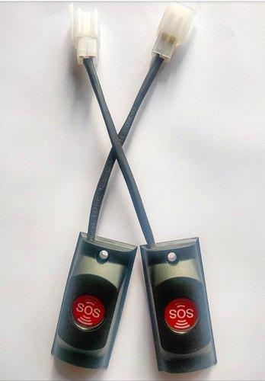

[38]

Pulse Rate Detector

This is a visual heart rate sensor that counts pulse rates and that unit converts into the volume of a blood vessel that takes place once the heart pumps the blood. The Pulse Sensor is a device that monitors pulse rates. A human's normal heart rate varies from 70 to 90 beats per minute. By clipping it in the fingertip, this sensor can detect the pulse rate.

A digital representation of the heartbeat is produced by the heart beat sensor. When the heart beat detector is turned on, the led flashes for each heart beat. To compute the BPM rate, this digital output will be directly coupled to the microcontroller. It is based on the light modulation of networked satellites and is traced to uplink data for synchronization.

The structure operates on four L-band frequencies ranging from 1.2 to 1.6 GHz.

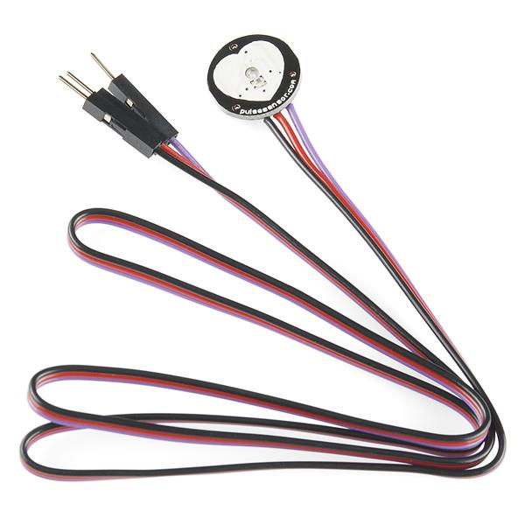

[39]

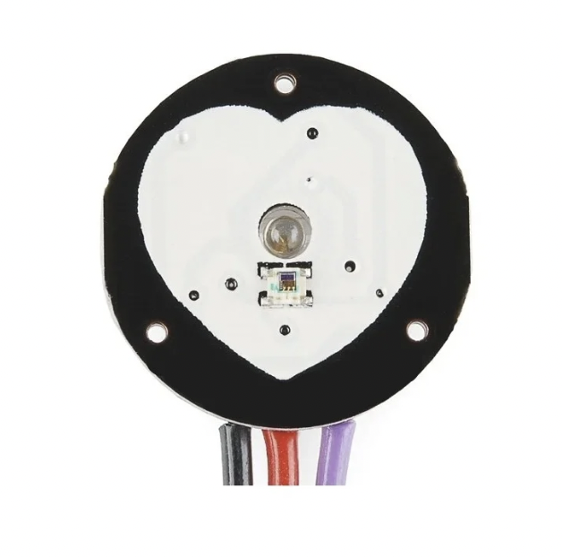

Temperature Sensor

The temperature sensor is an electronic device that is used to compute the temperature. This could be air temperature, fluid temperature or the temperature of rigid matter.

Unlike linear temperature sensors calibrated in Kelvin, the LM35 device does not require the user to subtract a high constant voltage from the output in order to achieve straightforward Centigrade scaling. The LM35 device does not require any external calibration or trimming to provide typical accuracies of 14°C at room temperature and 34°C throughout a temperature range of 55°C to 150°C. This is a straightforward DIY that may be used as a thermometer. It can detect and communicate the temperature it is exposed to in degrees Celsius. It is made up of relatively few parts and is both inexpensive and dependable. The temperature sensor used in this project is the LM35, which is the most often used. The Arduino temperature sensor transforms the air temperature to electricity. It also converts the voltage to Celcius, then to Fahrenheit, and displays the Fahrenheit temperature on the LCD panel. Using the Arduino to read the temperature is a very helpful activity. You may implement a range of temperature sensors in your projects, each with its own set of capabilities.

A temperature sensor is a device, usually a thermocouple or a resistance temperature detector, that uses an electrical signal to deliver temperature measurement in a readable form. A thermometer is the most basic type of temperature metre, and it is used to determine how hot or cold something.

[40]

A temperature sensor is a device that detects the degree of warmth or coolness in an item. The voltage across the diode determines how well a temperature metre works. The resistance of the diode is exactly proportional to the temperature change. The resistance decreases when the temperature drops, and vice versa.

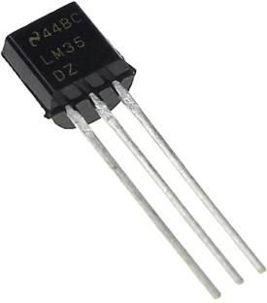

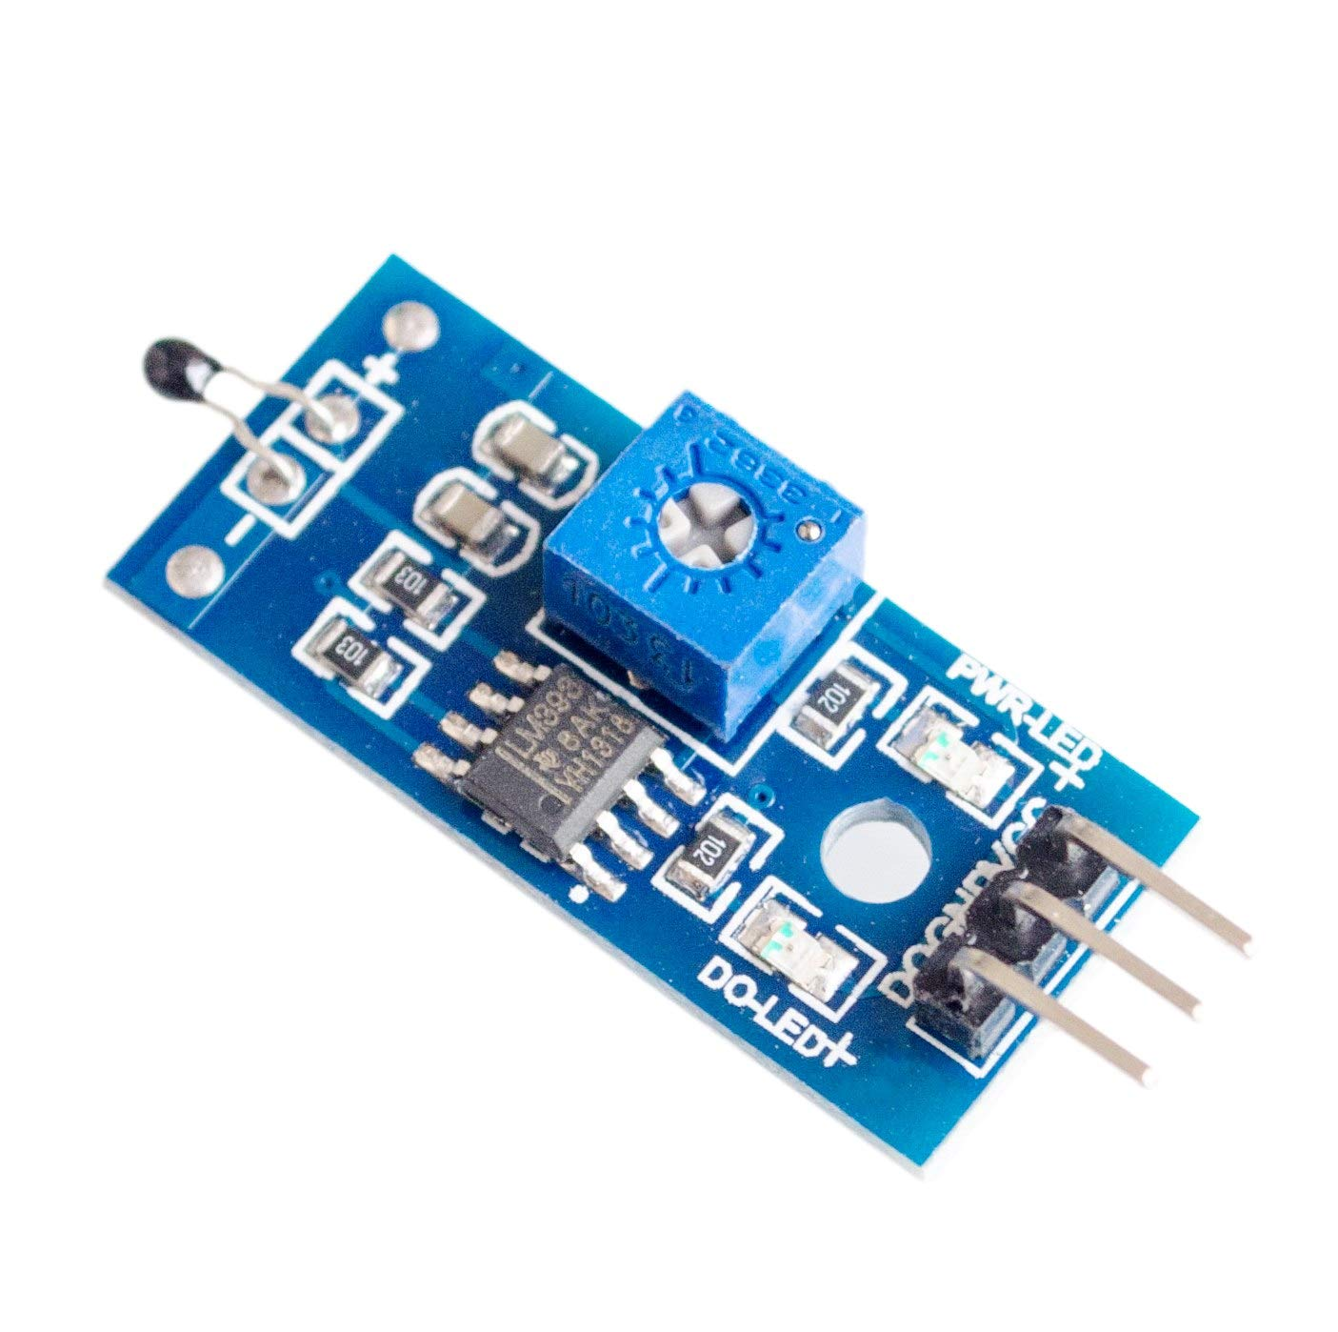

[41]

Wrist Band

Wristbands are enclosed strips that are worn on the corpus or the lower forearm and we can call it as a bracelet-like band. It holds the whole hardware of the watch to our wrist.

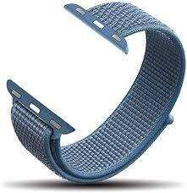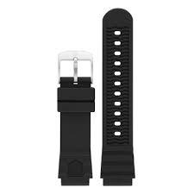

2 x 9V Cells

The nine-volt battery or 9-volt battery is a familiar size of the battery and it was established for prior transistor radios. It has a rectangular gem like structure with rounded-like edges and a contrary snap connector at its peak. After looking at a variety of Arduino battery power options, ranging from Lithium Backpacks to Minty Boost kits, I realised I didn't want anything so complicated. Granted, the 9 Volt battery isn't the most efficient for the task, and it's also the most expensive, but it's readily accessible and small.

[42]

It is also possible to connect the pins directly using a battery adaptor, but I prefer to use the DC power socket and avoid having any wires flowing to the pins.

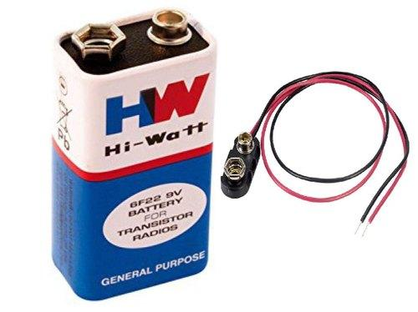

GPS MODULE

- System for tracking using GPS. It is the receiver that receives data from satellites and determines its location anywhere on the earth through using information it receives.

Its receiver sends out a signal that tells it where it is on the planet. The longitudinal and latitudes coordinates can be utilised for a variety of tasks, including vehicle navigation, search and rescue coordination, trail mapping, and terrain exploration. Buying and designing around a portable GPS receiver with a serial interface connection is a more cost-effective solution. RS232 It is created by the United States Department of Defence (DOD).

[43]

A complete serial data message comprising location, velocity, and time information is delivered at the serial interface when the GPS signal is applied to the antenna input of the module. The module provides data such as the current date, time, longitude, latitude, altitude, speed, and travel direction, among other things, and may be utilised in a variety of applications such as navigation, fleet management, tracking systems, mapping, and robotics. Up to 51 channels can be supported by the module. The GPS solution enables compact form factor devices to make significant improvements in GPS accuracy, integration, computational power, and flexibility. They're utilised to make the process of integrating embedded systems easier.

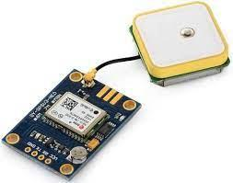

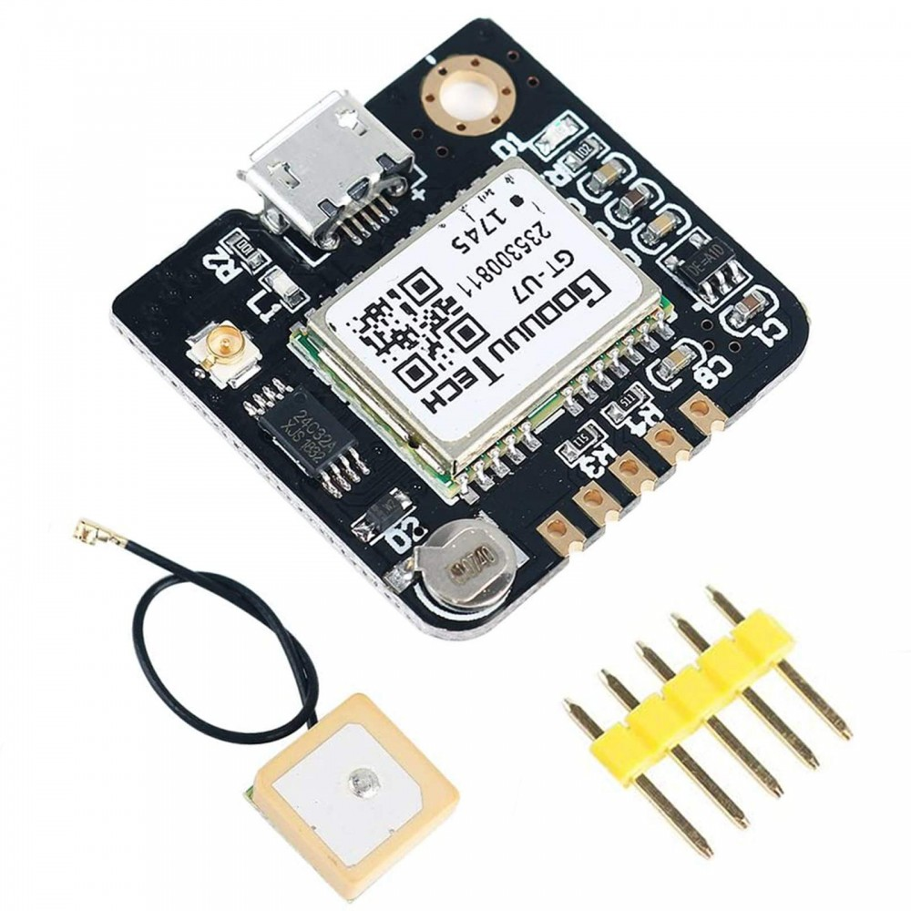

[44]

*BlockDiagram-*

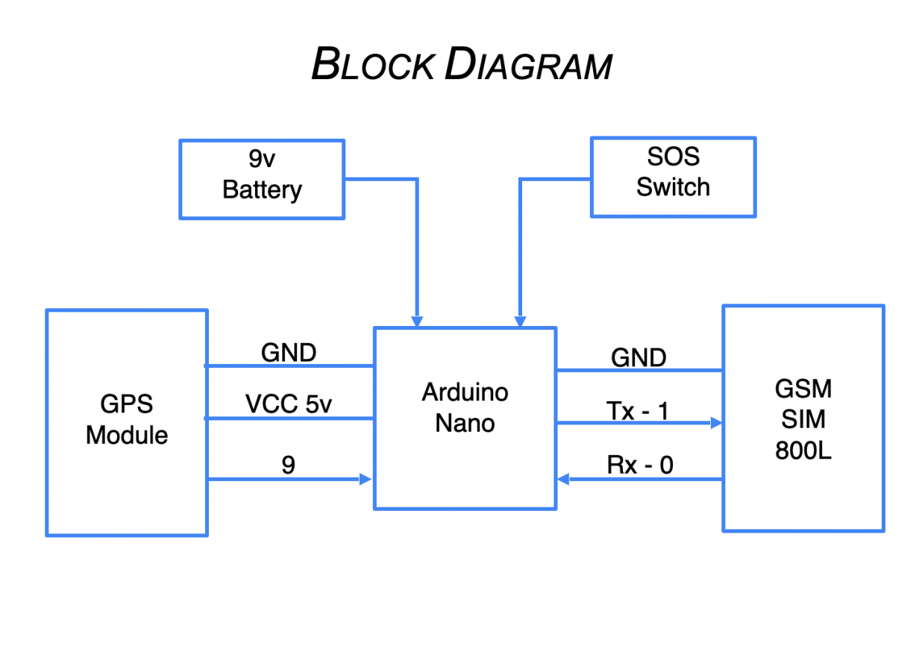

[45]

*Feasibility Analysis*

Economic Feasibility:

* As this IoT based project has been made through considering the cost, anyone can buy it easily.
* According to our understanding, it will have an overall cost of Rs 3500 only.
* The features that, it provides at this price range is amazing and hence it is pocket friendly too.
* Maintenance and repairing will have very minimal associated cost.
* User will experience many benefits at a very low cost.

Technical Feasibility:

* Ardiuno Nano.
* GSM Module.
* GSM Sim Tool.
* SOS Switch.
* Pulse Rate Sensor.
* Temperature Sensor.
* Wrist Band.
* 2 x 9V Cells.
* These tools are very efficient and are easily available.

Resource Feasibility:

* Programming Device such as Laptops.
* Wrist Bands that is easily available.
* 9V Cells that we can get at any nearby store.
* Ardiuno nano, which we can easily buy from any online store.

Time Feasibility:

* The time period for this project is provided by the mentor.
* This project will have several deadlines and deliverables that are schedules successively.
* Each part of the project has a deadline time to complete which makes this project time efficient.
* Hence, the development of the complete project is well planned and no delays expected resulting in a timely completion.

[46]

***SOFTWARE***

When the user's anomalous behaviour is discovered, the following procedures are taken. The inputs from numerous sensors such as the pulse sensor, temperature sensor, and unusual motion identified by the motion sensor are used to make the choice. The scenarios are pre-programmed in the system, depending on which the devices make decisions, and the smart phone application handles it all..

1.Allocates the transmitter and receiver pins of GPS modules.

2 Set the serial buffer to 9600 baud rate and 4800 bit rate.

3. Create a loop that will then activate the activities below:

a) Scan the contact number from SIM.

b) Convert the longitude and latitude obtained from GPS into a Goggle URL.

c) Attach this URL with an alert message.

d) Get data from GPS module.

e) Send this message to pre-selected ICE(In Case of Emergency) numbers from SIM memory.

When the pulse rate in this system exceeds the threshold pulse value, the system connects to the built-in smartphone application. The hardware and the mobile app are linked through Bluetooth with the help of a Bluetooth transceiver module. Android Software-Android Studio was used to create the mobile app.

Android Studio is Google's official integrated development environment, designed and optimised particularly for Android programming Android Studio is compatible with Python and Kotlin programming languages, and the most recent version is Android Studio 3.0.

[47]

**OBJECTIVES**

The major objective of the project is to design an IoT system called Smart safety band. Smart Watch contains a layer of sensors that can measure the biological boundaries of women in extreme conditions and 'triggers. Messages to caregivers and the purpose of the project is to design a portable watch to improve the safety of women.

To develop a product based for the emergency security purpose. There are many safety gadgets available in the market for the purpose of emergency safety needs but here our main aim is to propose a security wrist band which will be easily wearable device. Objective of the project is to design small wearable band to enhance the safety of the women.

This wearable device is part of the wearable gadgets family. It has a sensor layer that can assess the biological parameters of women in stressful situations and send signals to caregivers. The goal of the project is to build a compact wearable watch to improve women's safety.

As part of our literature review, we looked at several Android and other platform applications and devices that provide the same or similar services. The goal is to figure out how they operate and how they might be enhanced. Abuse against women is on the rise in today's world. In these sorts of situations, a smart gadget is critical for women's safety.

[48]

**RESULTS**

If the pulse level is higher than the threshold value GPS will come in handy and find the location.

‘Location and messages are sent to emergency contacts. Emergency contacts include the police helpline number and contacts of guardian and family members.

This type of idea, becoming the first of its kind, plays a critical part in assuring Women's Safety in the most efficient manner feasible. The suggested design will address significant challenges that women have experienced in the past years and will assist in their resolution using technologically sound devices

Accepted people open IP based on emergency contacts to watch live video, to help find the right justice for the victim. The buzzer activates when the pressure switch is pushed. The sufferer wears spectacles on the right side of the aspects.

The technology is capable of performing actual observation of the desired region and accurately detecting violence**.**

[49]

**CONCLUSION**

This report presents an emergence of important issues that young women face these days and can be technically disclosed using integrated tools and concepts. The wrist band victimization articulatio and mirrors, methods such as tear gas emitting, alarm bells, live video streaming and alert emergency contacts for causing location messages. This approach will overcome the fears that every girl in the nation fears about her safety and security.

This type of concept, becoming the first of its kind, plays a critical part in assuring Women's Safety in the most efficient manner feasible. The suggested design will address significant challenges that women have experienced in the past years and will assist in their resolution using technologically sound devices.With more study and invention, this concept might be used in a variety of security monitoring applications.The technology is capable of performing actual surveillance of the desired region and accurately detecting violence

The suggested design will address essential challenges that women have faced in the past and will assist in their illumination through innovatively stable equipment. With future study and development, this project might be used in a variety of security and reconnaissance areas. The framework is capable of doing continuous checks of the desired region and accurately identifying cruelty.The article discusses how to design for the important difficulties that women face today and how to tackle them technologically using little equipment and ideas. Mechanisms such as tear gas discharge, screaming alarms, live streaming video, and even notifying alternative contacts by sending messages with the location are all done with the use of a wrist band and spectacles. This method has the potential to alleviate the concern that every single woman in the nation has about her safety and security.This type of knowledge is critical in ensuring women's safety in the most expedient and self-defensible manner feasible. The suggested design will address significant difficulties that women have experienced in the current past and will use technology to assist solve them. With more creativity and study, this concept might be used in a variety of security and surveillance applications.

[50]

This technology can do real-time monitoring for a specific region. This method was created with the critical condition of women in mind. To offer women with protection as quickly as feasible. The suggested design will assist women in all key situations and will aid in the resolution of all challenges that women have encountered in recent years. The system was created with the most up-to-date technology in mind, ensuring that women have additional safety features.

Eventually, the conclusion is that there are several self-security bands on the market today. They are focused on body temperatures and blood pressures, though. As a result, there's a potential of misalignment. This self-security band, on the other hand, eliminates the possibility of misalignments and faults.

[51]

**REFERENCES**

1. Mr.Pampapathi B., Komal Singh , Madhavi, Madhu B Yallaraddi, Mangala Desai. “Internet of Things (IoT) based smartband - ensure the security of women”. International Journal of Advanced Research in Computer and Communication Engineering. Vol. 7, Issue 3, March 2018.
2. Surekha Gaonkar.“Emergency Tracking system for women using body Sensors via Wrist watches using Internet of Things (IOT)”. International Research Journal of Engineering and Technology (IRJET) Volume: 04 Issue: 08 | Aug -2017.
3. Ch.Ganapathi Pullaji. “IMPLEMENTATION OF WOMEN SELF SECURITY WRIST BAND”. International Journal of Engineering Applied Sciences and Technology, 2020 Vol. 5, Issue 1.
4. Geetha Pratyusha Miriyala. “SMART INTELLIGENT SECURITY SYSTEM FOR WOMEN” International Journal of Electronics and Communicational Engineering and Technology. Volume 7, Issue 2, March to April 2016.
5. “Res - Q - Smart Safety Band Automated heartbeat and fall monitor system”. Dev V. Savla; Soham Parekh; Ankit R. Gupta; Devansh Agarwal; Narendra M. Shekokar. Fourth International Conference 2020.
6. S. Sundar’s “Smart Band Protectoring”. International Journal Electrical Engineering and Technology (IJEET). March-April 2020.
7. Shivani Ahir. “The Personal Stun-A Smart Device For Women's Safety”. 2018 International Conference on Smart City and Emerging Technology (ICSCET).
8. “Safety Solution for Women Using Smart Band and CWS App”. A. Z. M. Tahmidul Kabir. 2020 17th International Conference on Electrical Engineering/Electronics, Computer.

[52]